 ***Complete***

***Firearms Maintenance***

***Cleaning Product Line***

***Formulated with 25 Years of Experience***

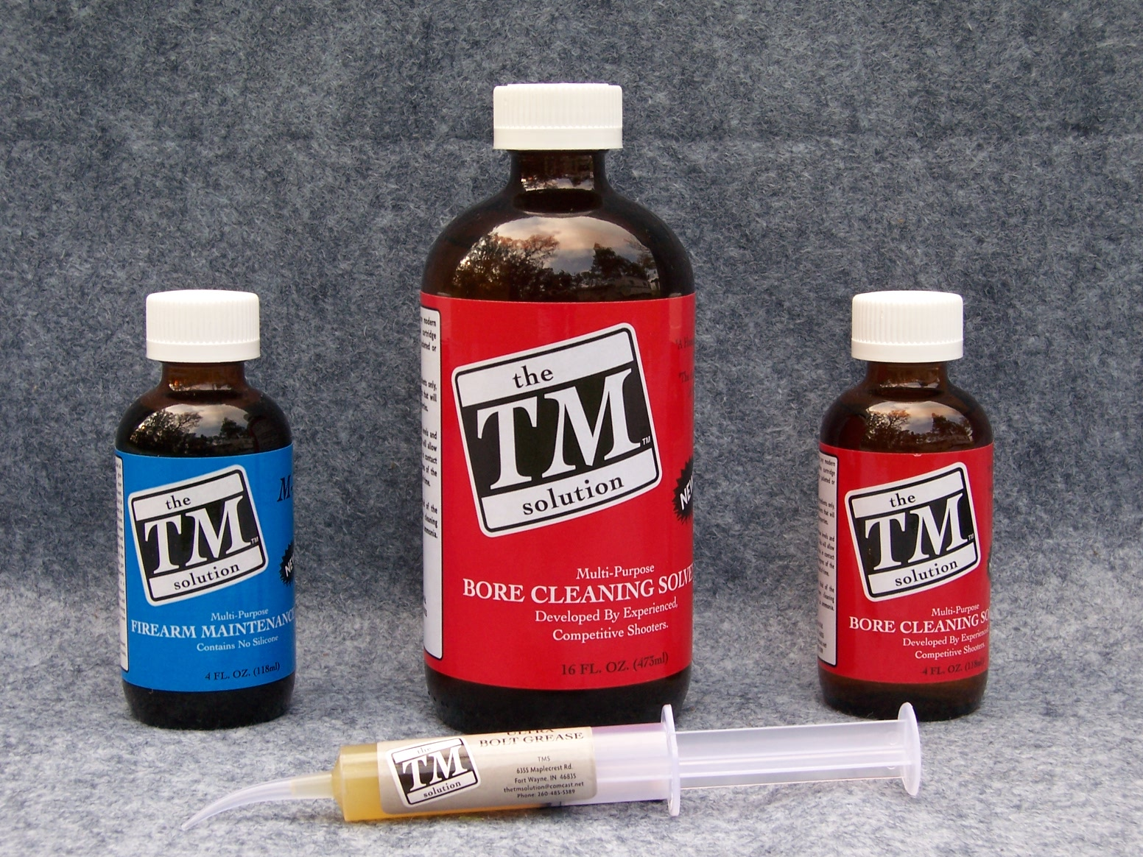

***Tom Meredith - Owner***

***Telephone/Fax: 260-485-5389***

***E-mail:*** [***tmstockworks1@frontier.com***](mailto:tmstockworks@comcast.net)

***Web Page:*** [***www.tmss.net***](http://www.tmss.net)

***About the Owner***

**My career started in 1976 sweeping floors at Sinclair International, a well known**

**shooting accessory business. As my interest in the shooting industry grew, Fred Sinclair**

**(my mentor and great friend) let me tag along to the rifle range, and started showing me**

**other areas of the business.**

**In 1977, Fred started showing me how to properly do stockwork. In October of**

**1988 Fred Sinclair sold the stockwork portion of the business to me, and “TM Stockworks”**

**was formed. I now have over 25 years experience specializing in hunting, varmint, benchrest, rimfire benchrest, 1000 yard benchrest, tactical, snipping, and high-power. I offer a wide**

**range of services, and a complete guarantee on services performed. I take great pride in my**

**work.**

**Then in the fall of 2003, during a conversation I was having with Fred about a**

**bedding release product a chemist friend was working on for me, Fred stated “Why not**

**come up with a bore cleaning solvent?” It was a comment that was typical of Fred. Although cleaning products available then were better than they ever had been, Fred thought it was**

**worth the effort to see if existing technology could be improved. I pondered on my conversation with Fred and followed up with my chemist.**

**In March of 2004, the formulation of “the *TM* solution” evolved from personal views**

**and desires regarding the characteristics that the ideal bore cleaning solvent should exhibit.**

**Testing by a number of well-known shooters and industry professionals, who include centerfire, rimfire, skeet and trap shooters, indicated I had attained my goal – and more. I**

**know that if you try my product line, you would agree.**

**From there, I added a Gun Oil (*TM* M-24) and grease (*TM* Ultra Bolt Grease) to**

**my product line.**

***TM Bore Cleaning Solvent***

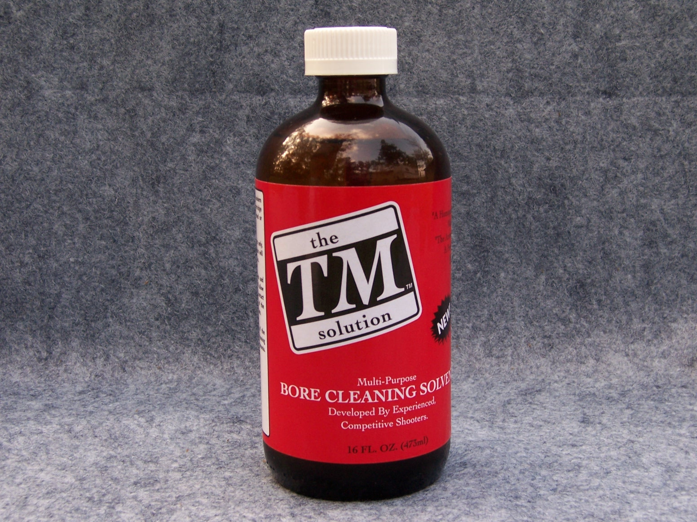

**Are you tired of Carbon, Copper, Lead & annoying**

**“*ammonia*” smells? Then *TM* Bore Cleaning Solvent**

**is your answer. It is ammonia free; starts dissolving**

**carbon & copper on contact AND it’s water-soluble.**

**GUNS Magazine, Hunting Editor, Holt Bodinson states:**

**“It’s the Crown Prince of Cleaners.”**

***Try it! You will agree!***

***Sizes: 4 oz. & 16 oz.***

**Other Information on Bore Cleaning Solvent**

**\*\*To be used with internal surface ONLY. Avoid contact with external surfaces\*\***

* **Non-petroleum based.**
* **A revolutionary gun-cleaning solvent capable of cleaning any modern centerfire, rimfire cartridge or muzzle-loading firearm.**
* **Goes to work immediately dissolving carbon, lead, plastic, black powder and powder fouling. Then works on any copper fouling.**
* **Contains no secondary ingredients that would reduce the cleaning properties.**
* **Not harmful to barrels.**
* **Bronze bore brush compatible.**
* **Water-soluble for easy cleanup.**
* **Low evaporation rate; clings to bore surfaces.**
* **Solvent remains in contact with the full 360 degrees of the bore.**
* **User friendly in smell.**

***TM* Ultra Bolt Grease**

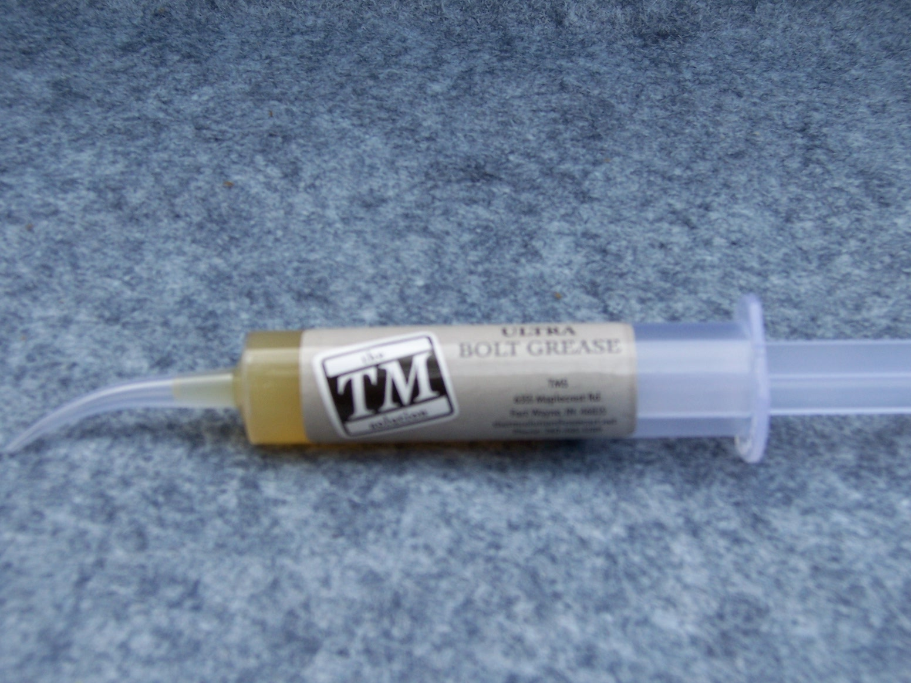

* ***TM* Ultra Bolt Grease is an extra-high performance, multi–purpose**

**grease with polymer additives, providing superior adhesive and**

**cohesive properties.**

* **Specifically formulated to provide superior performance in the**

**lubrication of high-load surfaces.**

* **The importance of lubricating these surfaces, especially in “trued” commercial actions and in custom actions, cannot be over-emphasized.**
* **The benefits of *TM* Ultra Bolt Grease are not limited to firearms. It is also great for fishing equipment, doors, locks, linkages, valves, chains, tools AND more.**
* **Size: 10 ml**

***TM* M-24 Firearms Maintenance Oil**

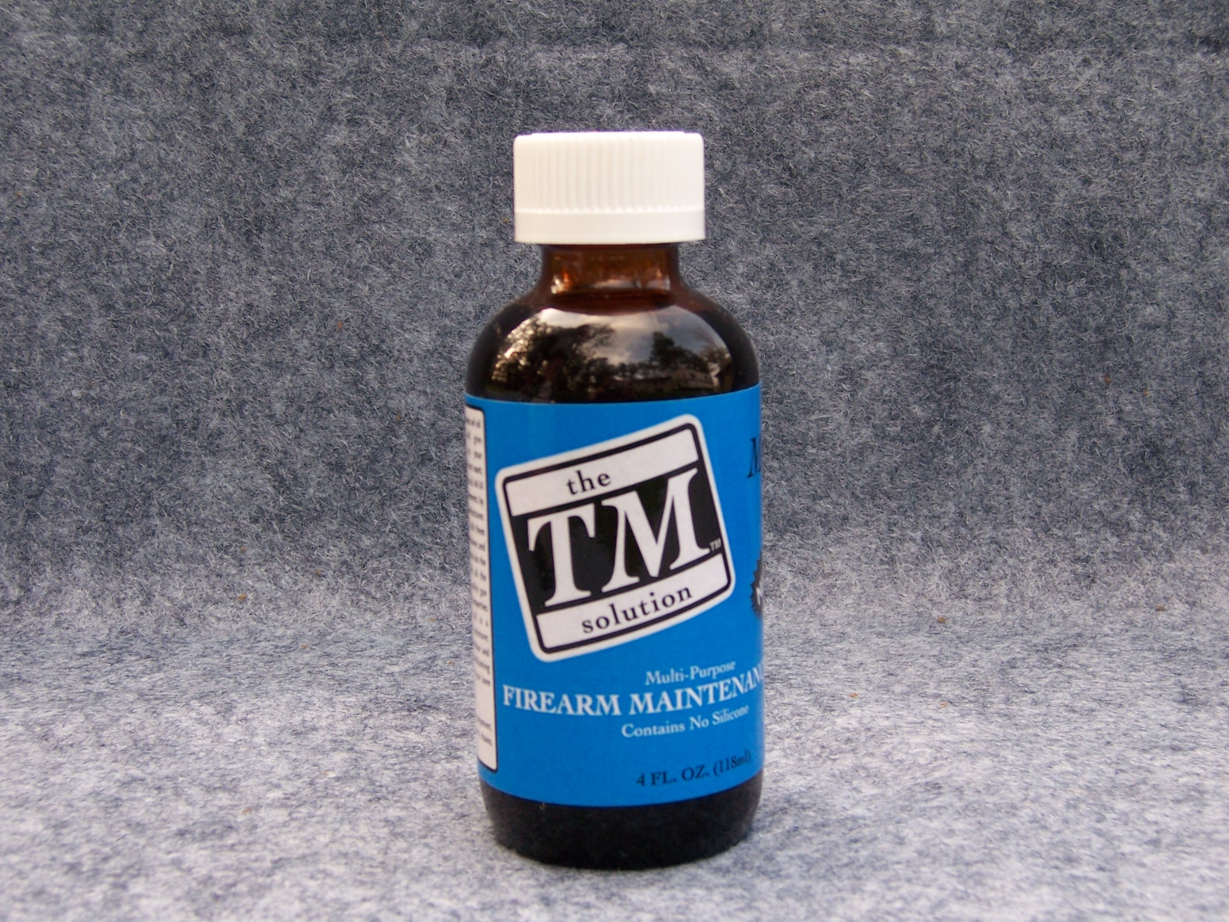

* ***TM* M-24 is blended with all the features needed in high-quality gun oil.**
* **It is free of silicone, making it an excellent lubricant.**
* **It has the properties of gauge-type machine oil.**
* **It is a penetrant and will displace moisture.**
* **It offers complete rust prevention.**
* **In short, it is the ideal bore-cleaning lubricant that offers maximum bore protection.**
* **But the benefits of *TM* M-24 are not limited to firearms. It is also great**

**for fishing equipment, doors, locks, linkage, valves, chains, tools AND more.**

* **Size: 4 oz.**

***Current Dealer’s***

* ***Brownell’s/Sinclair International – Fort Wayne, IN***
* ***Cabela’s – Retail stores & online store***
* ***ATF – Nashville, TN***
* ***ATF – Chicago, IL***
* ***Far East Gun Sales - Japan***
* ***Kelbly’s – North Lawrence, OH***
* ***Spencer Gunsmith – Scottsville, VA***
* ***Bruno Shooters Supply – Phoenix, AZ***
* ***Satern Custom Machining – Esterville, IA***
* ***BRT – Bench Rest Training – Australia*** 
  + ***Midway USA – Columbia, MO***
  + ***Pro-Cal Trading - Australia***

***Just to name a few***

**DEALER PRICE LIST – Effective 01-01-10**

|  |  |  |  |  |  |
| --- | --- | --- | --- | --- | --- |
| Item | Size | Case Qty. | MSRP | Dealer Price Each | Dealer  Price Case |
| ***TM*** Bore Cleaning Solvent | 4 oz. | 12 | $ 8.25 | $ 5.78 | $ 69.30 |
| ***TM*** Bore Cleaning Solvent | 16 oz. | 12 | $ 22.95 | $ 16.07 | $ 192.78 |
| ***TM*** M-24 gun oil | 4 oz. | 12 | $ 6.60 | $ 4.62 | $ 55.44 |
| ***TM*** Ultra Bolt Grease | 10 ml | 12 | $ 5.75 | $ 4.03 | $ 48.30 |

Dealer Prices for the ***TM*** products are for case lots only

12 units per case

***SHIPPING****:* ***Charges based on weight and area***

***\*\*Pricing is subject to change without notice\*\****

**Tom Meredith – Owner**

**Telephone/Fax: 260-485-5389**

**E-mail:** [**tmstockworks@frontier.com**](mailto:tmstockworks@comcast.net)

**Web Address:** [**www.tmss.net**](http://www.tmss.net)

***Testimonial***

After using your solvent, I can say for a fact I have not used a bore solvent that works as well. It is truly the only solvent I have found that will perform cleaning tasks for jacketed bullets, cast bullets and rimfire. You have certainly come up with an honest to goodness “multi-purpose” bore solvent. *It is an answer to my prayers*. I no longer have to have 4 or 5 different bottles of “stuff” to clean with.

I find that the time spent cleaning is noticeably less than with other solvents I was using. Firing 40 to 60 rounds require no more cleaning time than a 15-shot string.

Along those same lines, I have a 257 Roberts that copper fouls badly and after firing 5 to 10 rounds it use to take several cleaning sessions to clean. With your solvent, I do a routine cleaning, leave the bore wet over night, wipe it out and it is clean. The “tacky” feature of the solvent is a definite bonus when soaking a barrel.

Per your suggestion, I have also been using your M-24 oil as a bore conditioner prior to firing a cleaned rifle. This operation does have definite benefits. A damp patch, not wet, thru the bore prior to firing has reduced, if not eliminated that first shot “wandering off.”

Going a step further, I used the M-24 as a conditioner prior to the initial firing of two new barrels. Instead of my standard 1 to 3 shots and then clean “break in” routine, I fired 20 rounds between cleanings. Bore scope inspection of the barrels after a routine cleaning showed no signs of any fouling.

The M-24 rubbed into a piece of sheepskin works as well as any “wipe down” rust prevent I have used. It remains on the metal without becoming gummy as many do.

You have obviously done your “home work” developing these products and I’m sure they will do well. I would highly recommend them to anyone who cares about their firearms.

Fred Sinclair

Sinclair International - Fort Wayne, Indiana

***Testimonial***

I am as fastidious as they come when it comes to bore cleaners, lubricants and preservatives; and I test every new product that comes along, because I do A LOT OF CLEANING.

The TM solvent is sensational, not only on copper and carbon-fouled barrels but also on carbon, lead and plastic-fouled shotgun bores and carbon, lead and copper-fouled handgun bores and cylinders. I have to work with them all, and TM is up to the universal challenge.

As stated, the TM solution really does cling. When I look down the bore after running a patch through, TM’s in there covering the bore thoroughly and circumferentially 360 degrees.

***I call TM my "Crown Prince" of cleaning solvents.***

Holt Bodinson

Hunting and Shotgun Editor, GUNS

Magazine Ammunition, Ballistics and Components

***Testimonial***

Everyone knows that the finest barrels lose their edge if they are not cleaned  
properly.  There are several reliable solvents available to shooters, some have  
been around for a long time.  They work, but they do not work as thoroughly or  
quickly as TM Solution - simple as that.  TM Solution has simplified my barrel  
cleaning for one reason - it goes after carbon residue fast and simultaneously  
works on any copper deposits under the carbon.  I only use one solvent now and  
I do not have to use a lot of it.  That is how well TM Solution works.  I am  
also a believer in Tom's other products, his oil and grease are as dependable  
as the solvent.  Thanks Tom.  
  
   
Ian McMurchy  
Guns, Ammo and Optics Editor  
North American Hunter

***Testimonial***

I thought I had used every barrel cleaning solution on the market, until recently. On a nice day at the range, a fellow member offered me his TM Bore Cleaner to remove some visible copper streaks from one of my custom rifles that my myriad of cleaning solutions would not remove. I figured it was just some more “snake oil in a bottle” until I put it on a patch and ran it through the rifle bore.

*The solution is the most amazing bore cleaning* *solution I have ever seen*. It attacks carbon fouling like no other and it won’t quit until all of the carbon and copper is gone. No more need for the vast array of cleaning solutions/solvents since your bore solution performs like it does. Thanks for a fine product!!

Dave Poske

Dave Poske’s Performance Parts, Parkersburg, WV

***Testimonial***

     As you know I have been building Bench Rest rifles and

match grade barrels since 1979 and have used every solvent to

come along. Your TM solvent is the best I have ever used. It is,

without a doubt, the best carbon remover I have ever used and

works just great on copper. I, along with other barrel makers, will

tell you that if a solvent removes the carbon fouling, copper removal

is practically automatic. I feel that TM is the only solvent

(except for plain old Hoppes) that is safe when left in the bore

any length of time.

Every customer that I have given it to has said the same thing

and they return to buy more.

My customers come first. I owe it to them to recommend

products that I think are best. Your *TM solution* solvent is, in my

opinion, just that.

Best regards,

Clay Spencer – Spencer Rifle Barrels – Scottsville, Virginia

***Testimonial***

I had a new barrel at the time I got the TM Solution. With an

unfired barrel and a new solvent, why not use it exclusively

with this barrel. That is what I did, and I must say that the

Broughton barrel did not copper at all. I cleaned the barrel with

the new solvent before firing the first round, and I have not

had a copper-fouling problem since round one. Equally impressive

is its ability to remove carbon. This new product ***is amazing*** in

its ability to remove this black, accuracy-robbing demon. I

checked an old barrel after cleaning (with TM) with a borescope

and it failed to show the “black top road” carbon of most barrels

with 1500 rounds (like this one has). When I received this

product, I must confess that I said to myself … “Another bore

solvent; don’t we have enough now?” After using it for three months,

I must say it is my most-used solvent. *I can recommend this*

*product without reservation.*

James Mock

Precision Shooting Magazine

***Testimonial***

**Recently I purchased a 16 oz bottle TM Bore Cleaning Solvent from Sinclair International.   I think in the past fifty years I've tried just about every firearm**

**bore cleaning product that's been on the market.**

**Since I started using TM solvent I feel that I have found the perfect all around**

**bore cleaner!   It's not only does a great job getting the powder fouling out of**

**a barrel, it's the best copper remover I've found!**

**My cleaning method now is to use Tm Solvent at the range immediately after shooting while the barrel is still warm using normal cleaning procedures.  I**

**then leave the solution in the barrel overnight to remove any remaining traces**

**of copper.**

**The next day, a few patches through the barrel with your solvent followed by a couple of dry patches leaves a bright, copper free barrel.   A**

**patch moistened with a good quality gun oil finishes what used to be a time consuming chore!**

**Thank you for providing the shooting community with a very fine product.**

**Carl Alboth, Bonita Springs, Florida**

***Testimonial***

Used a Lee collect neck die as an expander on new brass – don’t ask. Galled brass

so heavily I could feel it with my fingernail. Ended up wrapping it in a TM Solution soaked

patch for half a day and the brass was just, well, gone. Under magnification nothing

was left but all the pits and scratches in the steel, not a trace of brass anywhere.

Amazing.

This after letting it sit an a new 5R barrel with some copper fouling in the rifling at the muzzle and having it gone after a few hours soak along with using an IOSSA heavy duty brush. Amazing again.

Dunno what this stuff is but thanks for bringing it to market. After decades of driving myself to distraction cleaning copper, or more accurately not cleaning copper, out of

barrels TM Solution finally makes the drudgery and danger of pitting a thing of the past.

Thanks again

Pete Goudreau

***Testimonial***

**I have been using the TM Bore Cleaning Solution that you folks**

**sent me and it is the finest bore cleaner I’ve ever used. You and**

**I have seen an untold number of bore cleaners come and go; most**

**of them are useless.**

**The TM Bore Cleaning Solution is different. It works and it leaves the bore squeaky-clean, with a minimum of cleaning rod strokes. I’m a true believer, when it comes to this product.**

**Steve Timm**

**Firearms Writer and Consultant**

**NRA Endowment Member**

**Articles**

Several articles have been written about my cleaning product line. They have appeared

in the following magazines:

* Precision Shooting – (James Mock) - September 2004
* Gun – (Japan) – (Turk) – September 2004
* Precision Shooting – (Jacob Gottfredson ) - May 2005
* GUNS Magazine – (Holt Bodinson) - September 2005
* BuckMaster – Gun Hunter – November 2005
* Cabela’s Outfitter Journal – (Joe Arterburn) – Sept./Oct. 2006
* The Varmit Hunter Magazine – October 2007
* The Varmit Hunter – October 2007
* Small Caliber News – (Steve Boelter ) – Winter 2007
* Outdoor Life – March 2008
* Precision Shooting – (James Mock) – March 2009
* Letter of appreciation – United States Marines Corp. – 2009